CLC --- Marketing Expenses, Perceptual Mapping, and Organizational Chart Analysis

CLC --- Marketing Expenses, Perceptual Mapping, and Organizational Chart Analysis
Part 1: Marketing Expenses Versus Rival Firms
Annual Report Information 2020
$ in Millions
Johnson & Johnson Procter & Gamble L’Oreal
Marketing/Advertising Expense $22,084 $19,994 $15,321
Though Johnson & Johnson (J & J) is participating in pharmaceutical, medical supplies, and consumer industries, J & J is one of the most successful businesses selling consumer products. J & J’s most popular consumer line of products are skin care products. The table below shows J & J's position in the industry compared to other competitors. Two competitors that were chosen are Proctor & Gamble and L’Oréal.

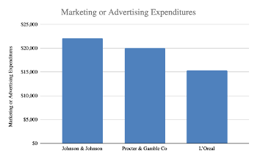

The chart above shows that Johnson & Johnson (J & J) has the most expenditures when it comes to marketing. In addition, the chart shows that J & J is striving to gain a competitive edge by promoting its products by presenting skin care products to as many consumers as possible through different marketing channels. J & J was able to remain strong through economic shifts due to the strength of its branding strategy along with strong relationships with distributors around the globe. For J & J to have continued success, marketing strategies must be created and implemented to expose more lines of skin products to customers.
Johnson and Johnson (J & J) must adopt strategies by budgeting funds out of the current advertising expenditures to further focus on presenting the brand to as many consumers as possible. J & J is known for creating stories in the form of short videos that utilize emotions to connect with its audience. Which allows J & J to convert possible consumers to repetitive customers and increase revenue. A strategy that J & J can utilize is providing customers with samples through trial subscription programs. Subscription programs allow the organization to showcase the line of products that the customers might consider purchasing (McCarthy, Fader, Hardie, 2017). Since J & J already has successfully built a brand that is known by many consumers in different parts of the world, providing free samples of skin products to interested customers. The advertising of the samples can be done through the current marketing channels that J & J uses. The marketing channels that J & J uses are social media, TV commercials, and google advertisements. When J & J sets a budget aside to provide more samples, the more likely that customers will purchase the products and continue participating in the monthly subscription to receive more valuable products.
Another strategy that Johnson & Johnson (J & J) can implement is through setting a budget aside to create a rewards program like the rewards program that is now used by companies such as Starbucks. The rewards program offers the consumers the opportunities to save money on future purchase of products by earning points. This strategy supports the idea of encouraging repetitive business and therefore can lead to a bigger return on the funds that are spent on advertisement. Each customer will have a personal profile through a mobile app that J & J can create and allow the customers to sign up for. In addition, the personal customization of the profile allows the customer to select favorite products and repurchase in the future.
The more Johnson & Johnson (J & J) gains a competitive edge with how well it is in allocating funds with the use of correct marketing strategies, the more J & J will be able to earn revenue and reuse the funds for further marketing. Though J & J has competitors in the market with similar consumer products, J & J always has the advantage of having a strong brand name that is trusted by many healthcare agencies around the world. Therefore, with the strong branding and the investments in the new marketing strategies, J & J will continue to prosper among other companies in the industry.
Part 2: Perceptual Mapping
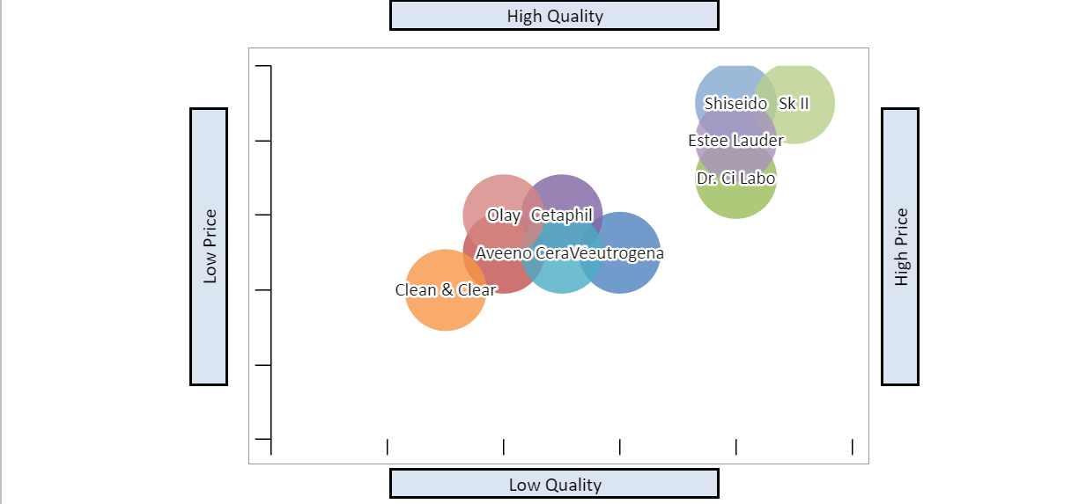

This perceptual map is for Johnson & Johnson’s (J & J) skin care brands and six competitors. Since J & J competes in the pharmaceutical, medical devices, and consumer health industry, there is no direct competitor. The perceptual map will focus on J & J’s skin care products, which includes Neutrogena, Aveeno, Clean & Clear, and Dr. CiLabo, against competitors for price and quality. Using these products with perceptual mapping helps strategists ensure that money for marketing is spent wisely (David et al., 2020). This map will also help the company understand which brands are doing well, identify problems with under performing brands, and to visualize potential markets that could serve as a new focus for the company (David et al., 2020).
All four Johnson & Johnson (J & J) brands span multiple price points and cater to multiple audiences. The organization does well for having all products dermatologists recommended. In the US, J & J products have the highest market share for skin health products with 52% (Diment, 2020). It is not recommended diversifying the brands, but to have Clean & Clear’s marketing team focus on spotlighting that its products do not contain fragrance or dyes and does not leave residue after rinsing (Diment, 2020). The same recommendation would be suggested for Dr. CiLabo’s and focus that this brand is the number one doctor recommended products. With focus on Clean & Clean and Dr. CiLabo, this will boost awareness of the both brands.
Part 3: Organizational Chart Analysis
Current Organization Chart:
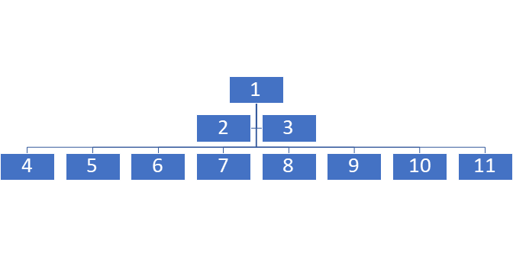

1 -- Chairman of the Board/CEO
2 -- Vice Chairman of Executive Committee
3 -- Vice Chairman of Executive Committee and Chief Scientific Officer
4 -- Executive Vice President, Chief Human Resources Officer
5-- Executive Vice President, Worldwide Chairman, Medical Devices
6 -- Executive Vice President, Worldwide Chairman, Consumer Health
7 -- Executive Vice President, Global Corporate Affairs Officer & Chief Communications Officer
8 -- Executive Vice President, Worldwide Chairman, Pharmaceuticals
9 -- Executive Vice President, General Counsel
10 -- Executive Vice President & Chief Global Supply Chain Officer
11 -- Executive Vice President & Chief Financial Officer

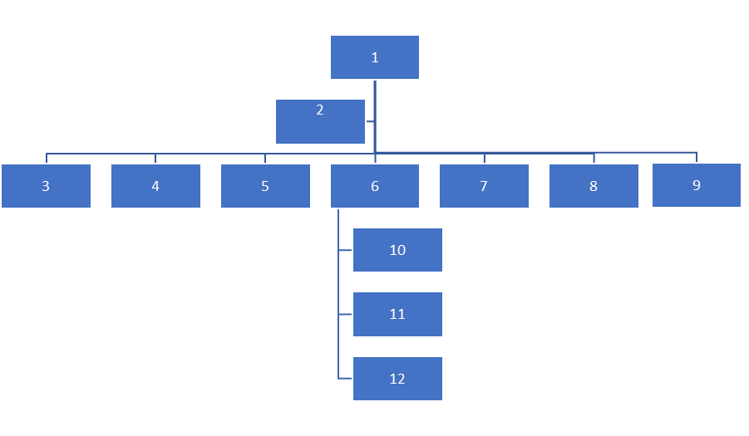

1 -- Chairperson of the Board
2 -- CEO
3 -- Chief Scientific Officer
4 -- Chief Human Resources Officer
5 -- Chief Global Corporate Affairs Officer
6 -- Chief Financial Officer
7 -- Chief Communications Officer
8 -- Chief General Counsel
9 -- Chief Global Supply Chain Officer
10 -- President of Worldwide Pharmaceuticals
11 -- President of Worldwide Medical Devices
12 -- President of Worldwide Consumer Health

Marketing refers to a tactic that is a long-standing plan that guarantees an organization attains a competitive advantage in marketplaces and gains market diffusion in new markets. Marketing expenses entail the number of financial resources that an organization uses for marketing. It may involve promotions, advertisements, public relations, marketing research, and marketing salary costs. This paper focuses on reviewing the implication of marketing expenditures of the Johnson & Johnson (J & J) organization. J & J is a multinational corporation that develops pharmaceuticals, consumer health products, and medical devices. Since J & J have a lot of competitors such as Procter and Gamble company, they require effective marketing and advertising strategies for their products.
Therefore, from the report, it is effective to conclude that they have spent $22,084 million on marketing, which is over $3,000 million more compared to Procter and Gamble whose expenses are at $19,994 million. Their major aim was to improve the marketing shares for their skincare products from 52% or more by ensuring that the brand awareness of products such as Dr. CiLabo and Clean & Clear are raised within their target population. Since the target company of Johnson & Johnson (J & J) involves people of different ages, races, ethnicities, and gender, their marketing expenses focus on both online and offline marketing. That is, according to an article by (Chen, 2011), effective marketing strategies comprise marketing through social networks, advertising through media and viral markets, point-of-purchasing marketing, direct selling, discount and promotions, use of social media, and direct selling. Moreover, their marketing expenses also focused on creating a spotlight on the products that do not have any fragrance, and on the dyes that do not leave residues after rinsing.
In summary, it is effective to conclude that the kind of marketing strategies utilized by Johnson & Johnson played a major role in raising the advertisement expenses. Moreover, having strong competitors such as Procter and Gamble, and Unilever makes them put extra costs on marketing to ensure that they stand out and attain a competitive advantage over them. Therefore, an organization needs to understand what marketing strategies are effective to ensure that additional costs are not incurred.

References
David, F. R., David, F. R., & David, M. E. (2020). Strategic management concepts and cases: A competitive advantage approach (17th ed.). New York, NY: Pearson Education.
Diment, D. (2020). Acne treatment manufacturing OTC. https://my-ibisworld-com.lopes.idm.oclc.org/us/en/industry-specialized/od4125/about
Johnson & Johnson. (2021). Investors information. www.investor.jnj.com
Johnson & Johnson. (2021). Our leadership team. https://www.jnj.com/leadership/our-leadership-team?utm_source=bing&utm_medium=cpc&utm_campaign=BI-USA-ENG-PS-Corporate+Equity-BC-EX-RN-BRAND_LEADERSHIP&utm_content=J%26J+-+Leadership+-+General+-+E&utm_term=johnson+and+johnson+executives&gclid=a44c9734ffca1be220adf7e05b8a56a9&gclsrc=3p.ds&ds_rl=1262818&msclkid=a44c9734ffca1be220adf7e05b8a56a9
Leighton, M. & Decker-Jacoby, K. (2021). The Insider reviews team test hundreds of skincare brands each year – these are the 24 we keep coming back to. https://www.insider.com/best-skincare-brands
McCarthy, D. M., Fader, P. S., & Hardie, B. G. S. (2017). Valuing subscription-based businesses using publicly disclosed customer data. Journal of Marketing, 81(1), 17–35. https://doi-org.lopes.idm.oclc.org/10.1509/jm.15.0519
Procter & Gamble. (20210. 2020 annual report. https://us.pg.com/annualreport2020/annual-report-downloads/
Rosenstien, J. (2021). The 35 best skincare brands. https://www.harpersbazaar.com/beauty/skin-care/g19738338/best-skin-care-brands
Thomas, B. (2021). Cosmetic & beauty products manufacturing in the US. https://my-ibisworld-com.lopes.idm.oclc.org/us/en/industry/32562/major-companies
Yahoo! Finance. (2021). L’oreal income statement. https://finance.yahoo.com/quote/OR.PA/financials/

